EEZ BB3 kit assembly instructions

Introduction
Instructions presented in this document are related to BB3 - Two Channel (Full) kit offered through a crowdfunding campaign.

The EEZ BB3 kit is not an end user product. As such, it has not been subjected to any conformance testing, and it may not comply with some or any technical or legal requirement that are applicable to finished products including, without limitation, directives regarding electromagnetic compatibility, recycling (WEEE), FCC, CE, or UL. Assembling and using the EEZ BB3 requires an understanding of electronic circuits and basic computer programming skills.

If you need assistance, please contact us using this form or post your problem on the EEVblog forum here. Or, feel free to open a New issue on GitHub here, but please check first to see whether a similar issue already exists).

The only tool required for kit mechanical assembly is a medium Phillips head screwdriver. Of course, a multimeter for checking the wiring and voltage at a few points during assembly is recommended.

Before you start
We made our best effort to make your EEZ BB3 kit complete and functional. However, please note that due to limited resources, the kit is not completely and thoroughly tested. Basic testing was performed on modules (core and power) and cooling fan.

Modules are tested on our “testbed” but not using the wire harness and AC/DC modules that comes with your kit. Therefore, it’s highly recommended that you check visually, mechanically and with ohmmeter whether cables are properly assembled before you proceed with final assembly (consult Wire harness section).

The basic testing covered communication over Ethernet, fan control, power control, touchscreen functionality, beeper, TFT display and output voltage and current programming in a whole range (i.e. up to 40 V and 5 A with connected load). The AC/DC modules are capable of working with both 115 and 230 Vac.

Kit assembly steps
- Package content
- Plastic bags content
- Bottom plate
- Installing MCU and BP3C
- Connecting TFT display
- Front panel mounting
- Installing AUX-PS module
- Rear panel mounting and cable connection
- First power up and installation of power modules
- User manual and firmware update

Package content
The BB3 kit consists of the following parts, as shown in Fig. 1 and Fig. 2:

Item | Description
1 | Pre-drilled enclosure top plate
2 | Pre-drilled enclosure bottom plate
3 | Enclosure front panel with mounted 4.3” TFT touch-screen color display
4 | Enclosure rear panel with mounted Ø80 mm cooling fan
5 | Mean Well AC/DC converters mounting frame
6 | Plastic bag with wire harness and miscellaneous mounting parts
7 | Core modules (AUX-PS, MCU and BP3C) and micro SD card
8 | DCP405 power module x2
9 | Mean Well 48 Vdc AC/DC converter x2

Please note that AC power cord is not included with this kit.

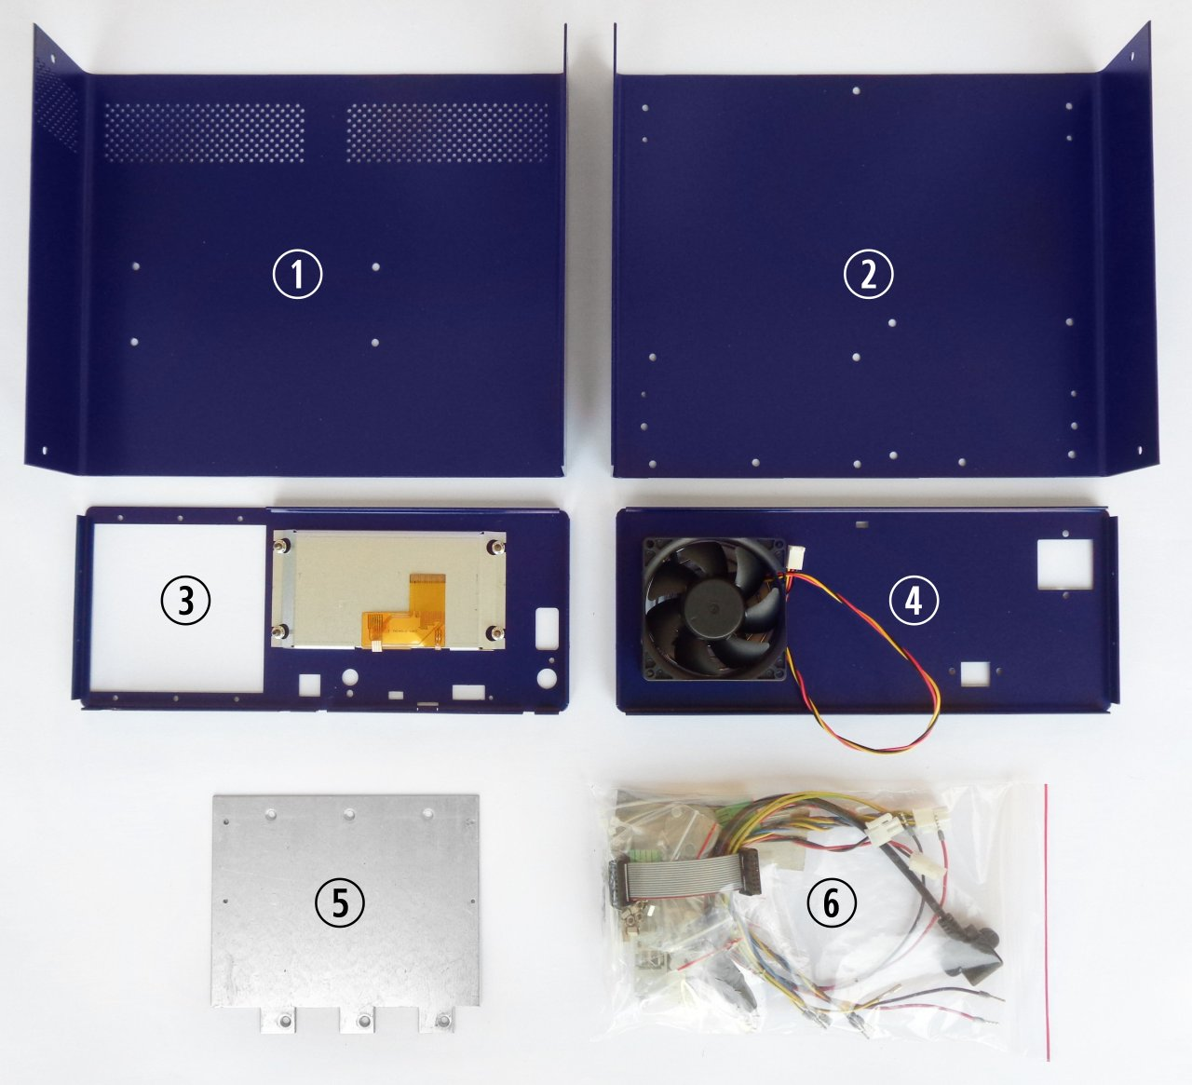Fig. 1: BB3 kit content

Plastic bag content
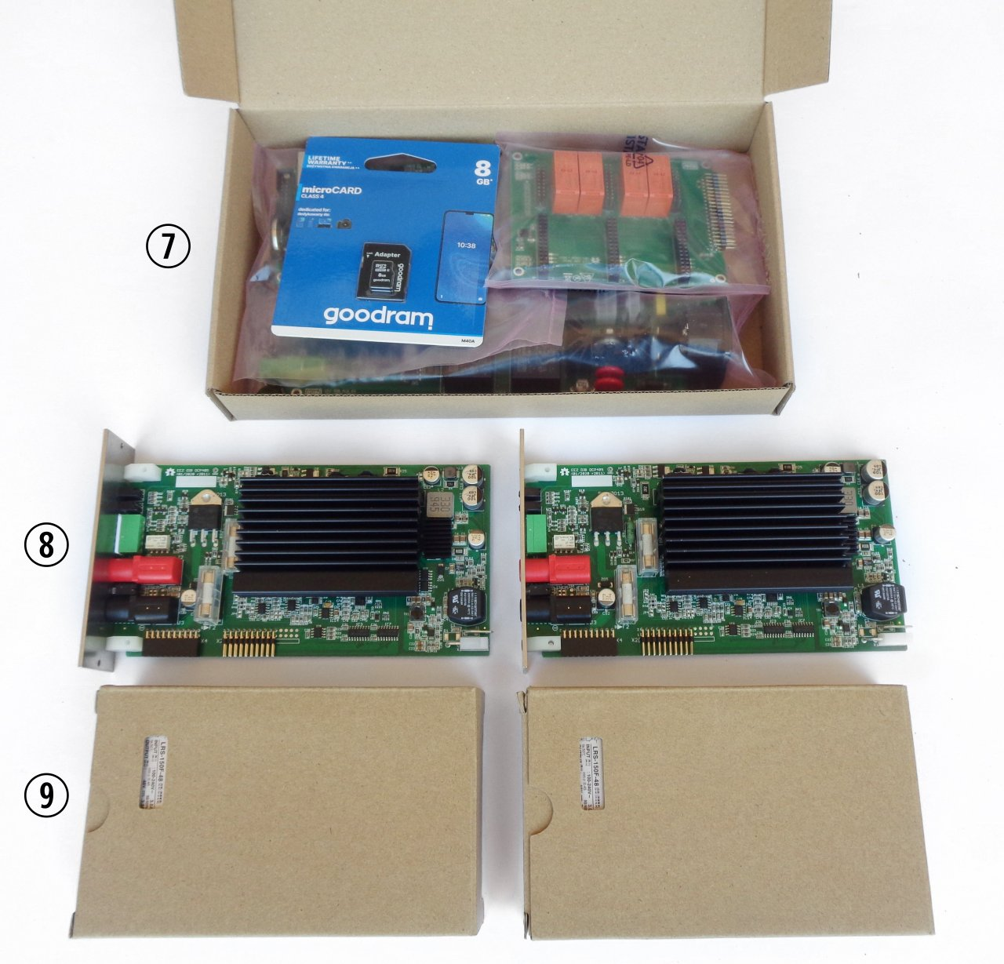Fig. 2: BB3 kit content (cont.)
Before start assembling please take some time to check if the contents of the plastic bag (item 6) includes all what is listed below. Also familiarize yourself with Items naming that will be used in the rest of the document.

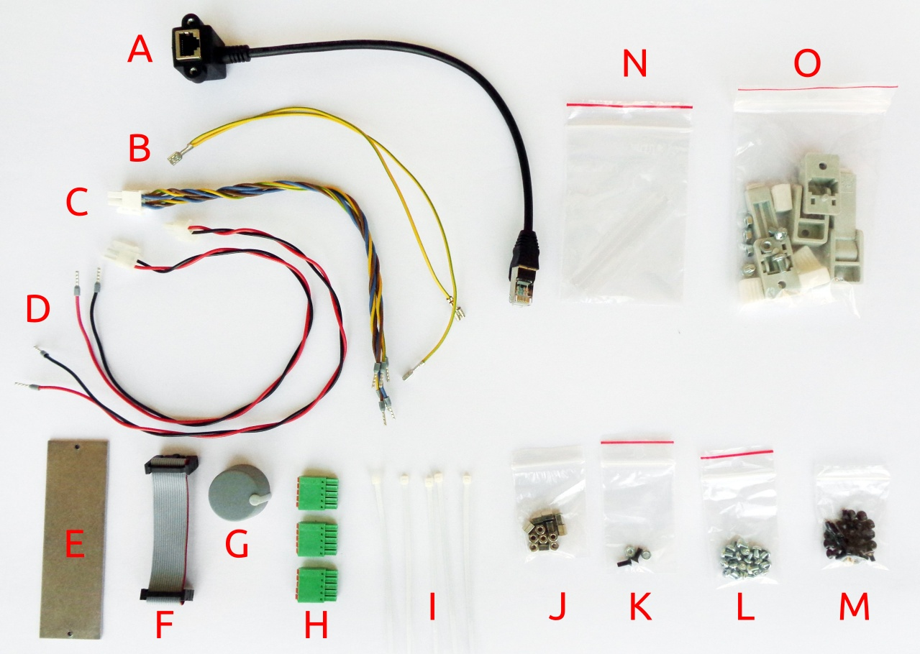Fig. 3: Plastic bag content
Item | Description
A | Ethernet patch cable
B | Dual power module PE (Protective Earth) cable
C | Dual AC/DC power module AC input cable
D | Power module DC input cable
E | Blind module front panel
F | 16-pin IDC flat cable
G | Encoder knob
H | 5-pin push-in connectors
I | Cable ties xQUANTITY
J | Hexagonal M3x6 mm metal spacers xQUANTITY
K | Mounting set for AC power inlet
L | M3x4 mm screws xQUANTITY
M | M3x5 mm countersunk screws xQUANTITY
N | Mean Well terminal covers
O | Enclosure feet kit

Bottom plate
As a first step, plastic feet will be mounted. Identify foot holes on the bottom plate (Fig. 4.) and unpack the content of the bag with feet parts (Item O, Fig. 3.). Front feet come with an extended part that, when mounted and folded out, can set the enclosure at an angle.

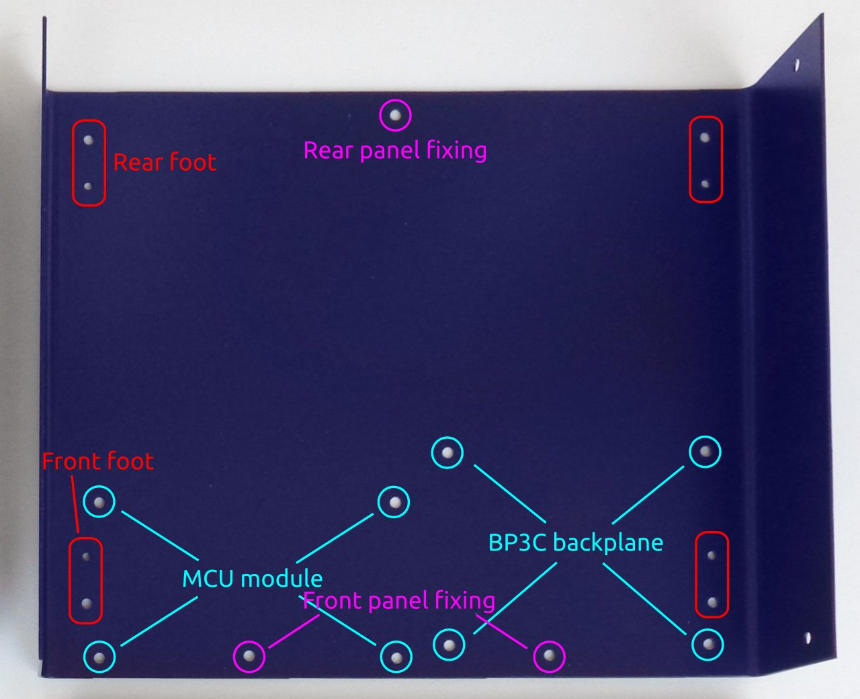Fig. 4: Enclosure bottom plate
The M4 screw mounts into a larger hole as shown in Fig. 5. Once the foot is secured, the rubber part can be pushed in to hide the screw head.

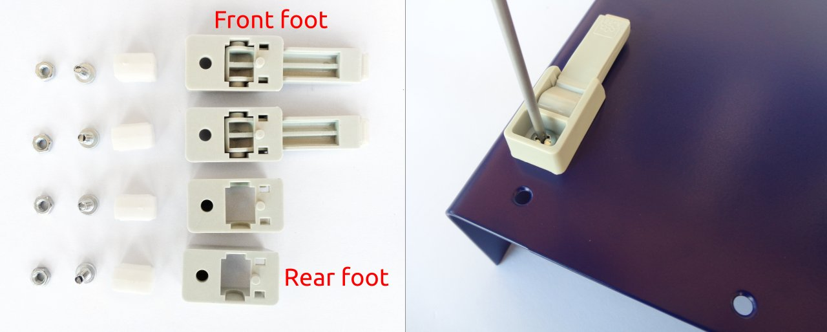Fig. 5: Feet parts and front foot mounting
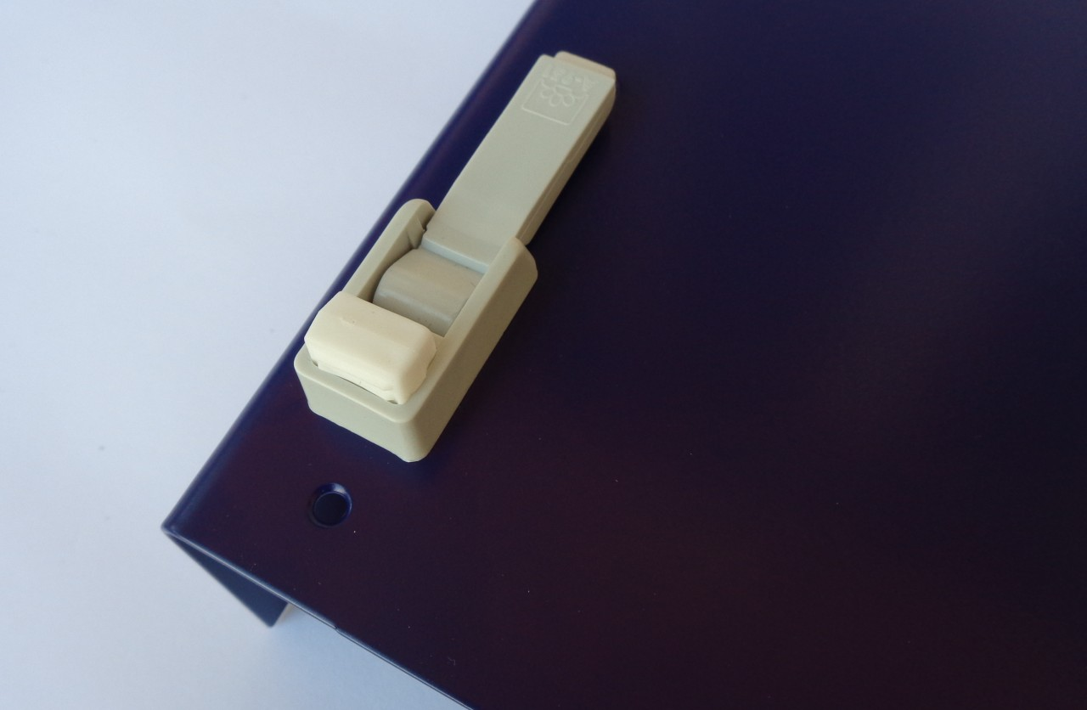Fig. 6: Front foot mounting completed
Differently inserted rubber inserts may cause the bottom plate not to be leveled. If you wish to level at this point, press carefully along the ends of the bottom panel until a satisfactory result is obtained. The final leveling can also be done after all the components have been installed and the top panel mounted. This is a recommended method because it is less likely to cause the bottom plate to deform in the process of leveling.

Installing MCU and BP3C
Remove the MCU module from the package. Take care not to place it on any conductive surface to avoid short circuits, as it comes with a battery installed. Fig. 7 shows the parts (according to the markings in Fig. 3) required for mounting this module.
Attach the hexagonal metal spacers (J) using screws (L) to the four holes in the corners of the module. Repeat the same procedure on the BP3C backplane shown in Fig. 8.
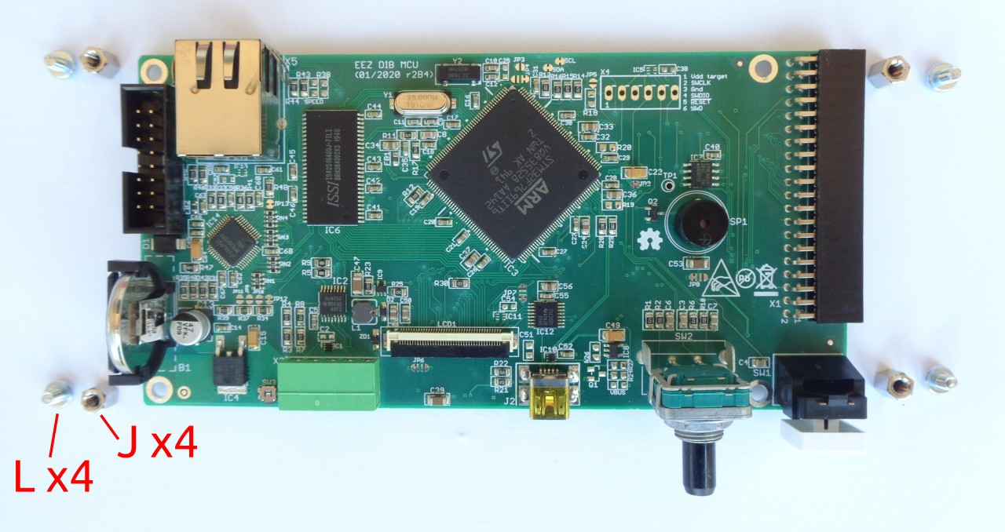Fig. 7: MCU module with mounting parts

Carefully connect the modules together (40-pin X1 socket on MCU module side and X5 header on BP3C side). You can now proceed with mounting the module to the bottom panel using screws (item M in Fig. 3) in the positions shown in Fig. 4.
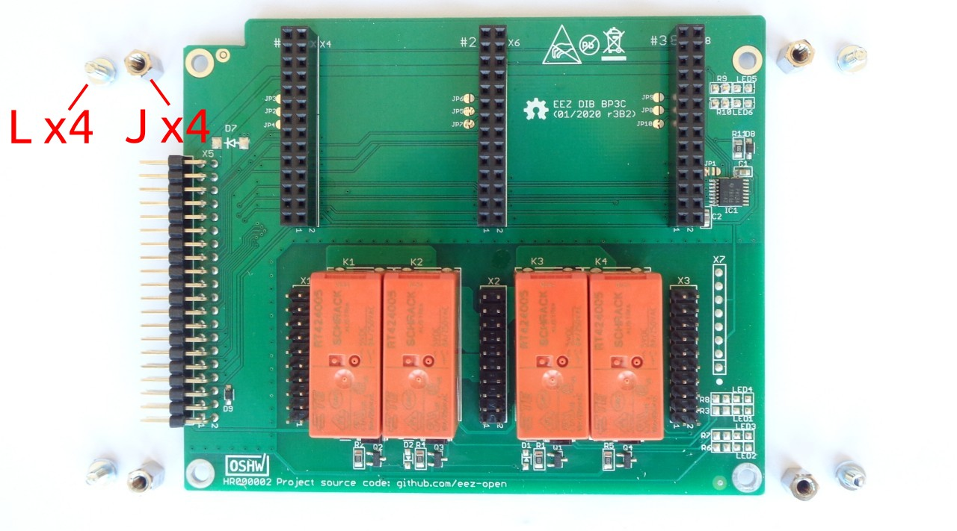Fig. 8: BP3C backplane with mounting parts

Do not completely tighten these screws before installing the front panel.

Connecting TFT display
In order to mount the front panel to the bottom panel, it will be necessary to connect the TFT display to the MCU module, first. This is the most delicate operation in the entire EEZ BB3 assembly procedure, so it requires extra care.

First, identify the connector position on the MCU module and carefully place the black plastic lever in the up position (Fig. 9) to allow the display flat flexible cable to enter smoothly.
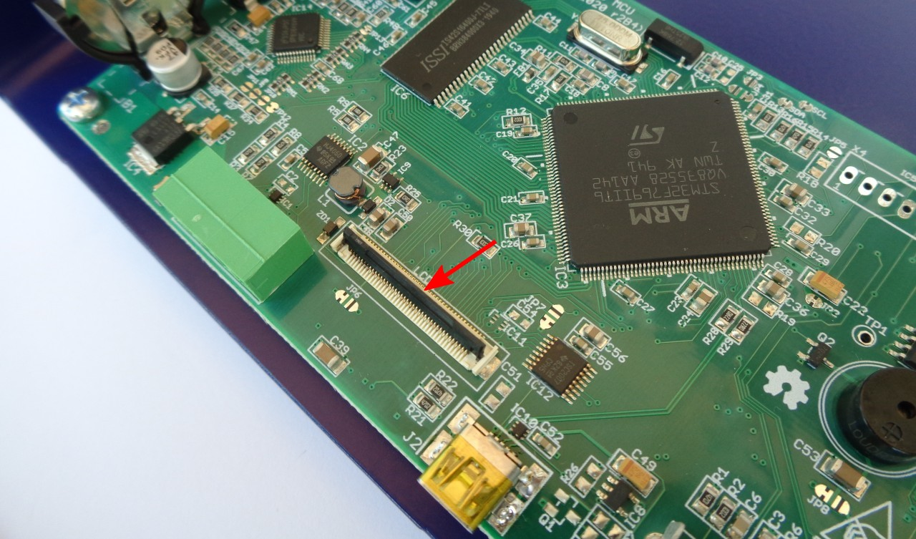Fig. 9: 40-pin FFC display connector

Do not power on the MCU module without the display connected or with a loosely connected flexible display cable. Doing so may damage the power supply of the display backlight located on the MCU module.

Front panel mounting
Carefully bend the display cable so that it is in line with the FFC connector and slowly insert it (Fig. 10). When the flexible display cable is in place, lower the black lever to lock the cable (Fig. 11).

Do not force the flexible cable into the FFC connector as it may damage the cable and the connector.

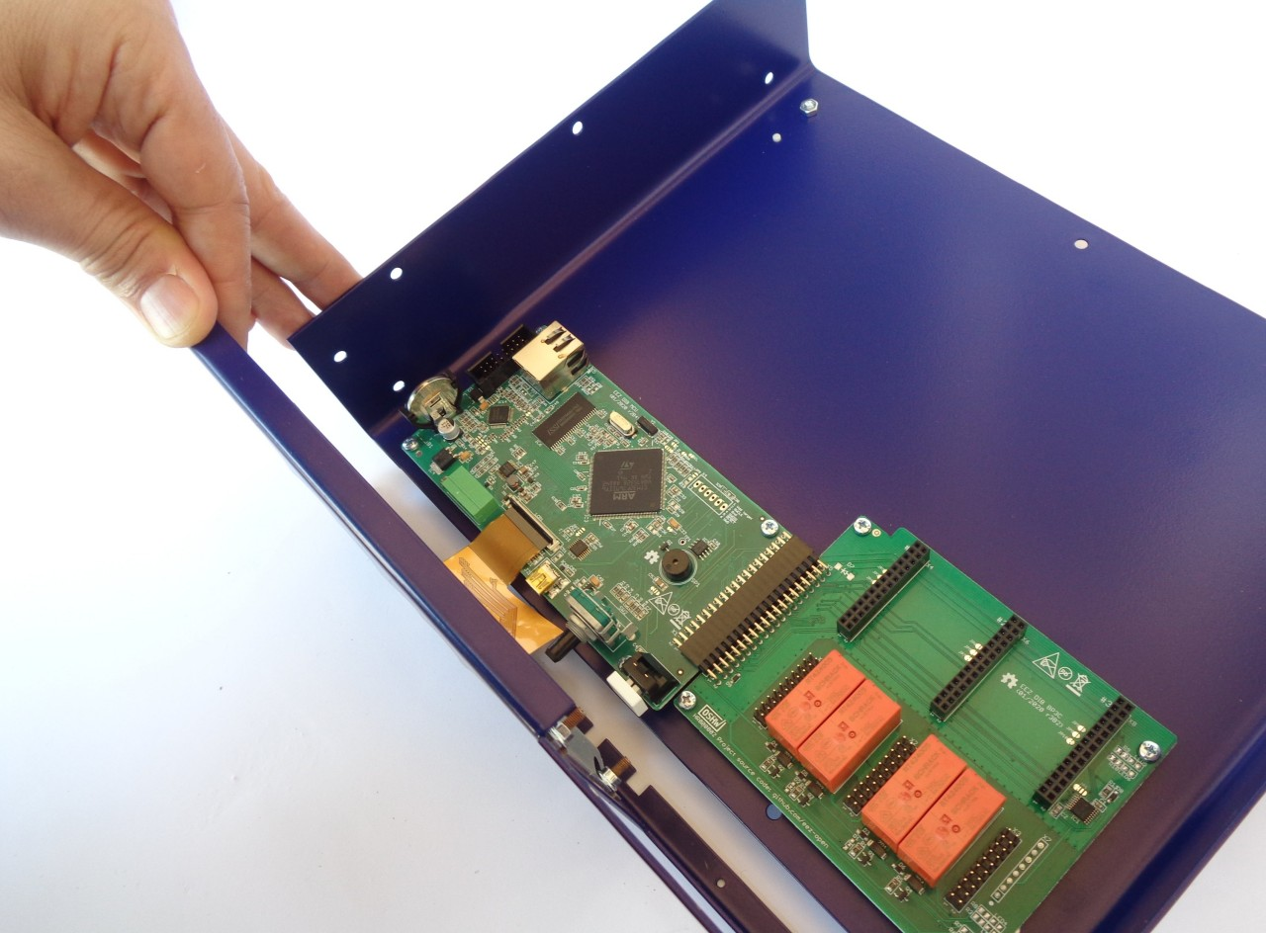Fig. 10: Inserting display flexible cable into 40-pin FFC connector

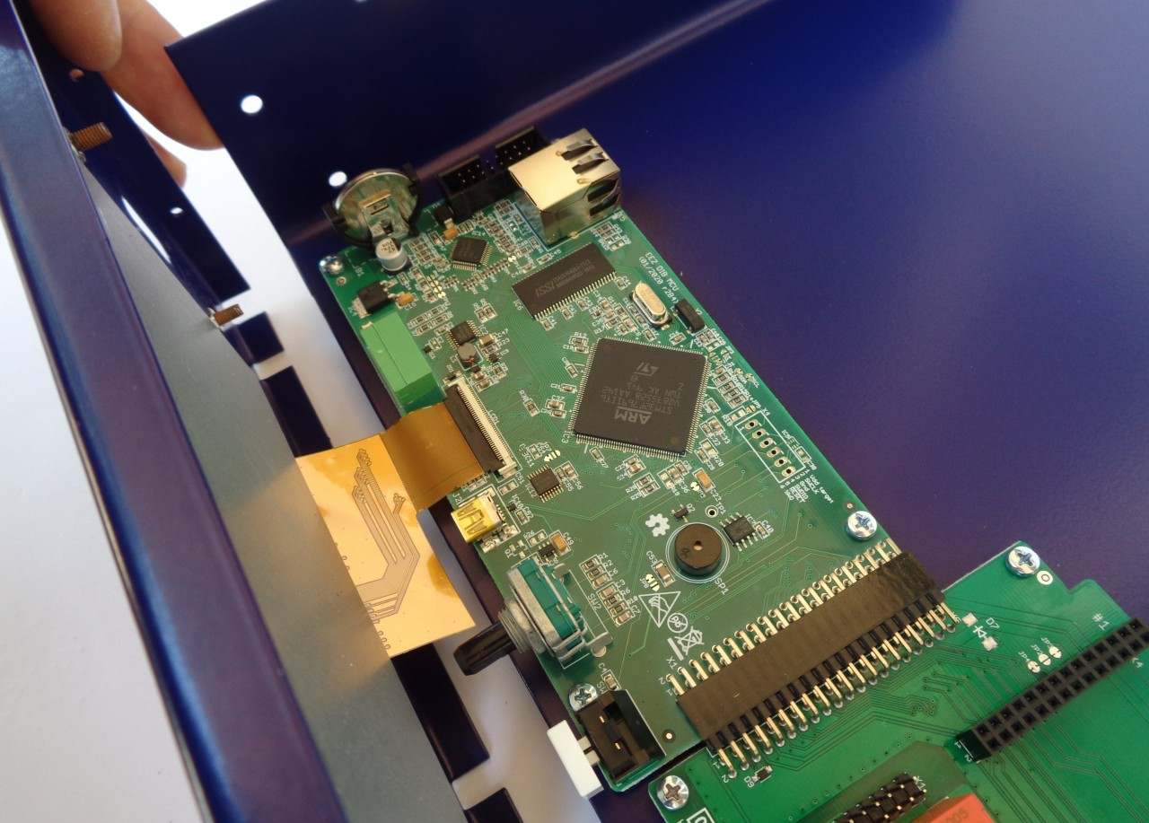Fig. 11: 40-pin FFC connector in lock position
Before proceeding with fixing the front panel to the bottom plate, check that the encoder shaft and user switch are in place (Fig. 12). Additionally, check that the User switch is functional (Fig. 13); that it is not pinched and that it can be depressed.

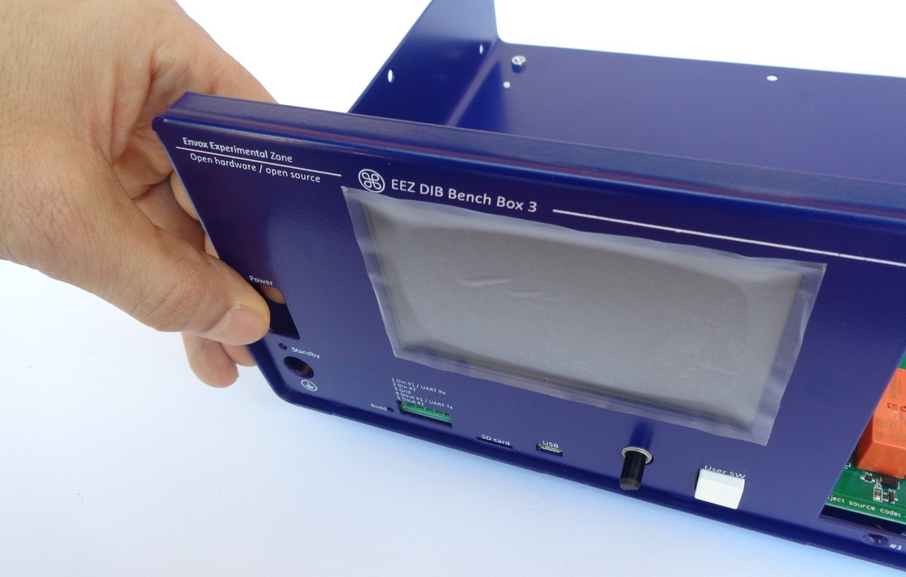Fig. 12: Checking that the encoder shaft and user switch are in place

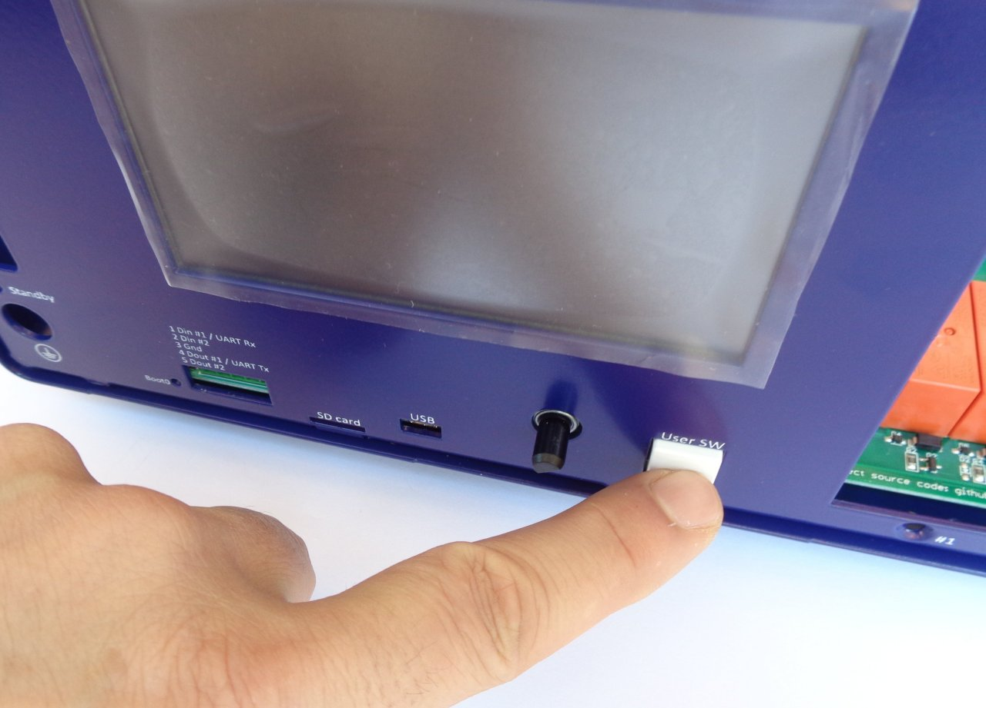Fig. 13: Checking that the user switch works (that it is not pinched)
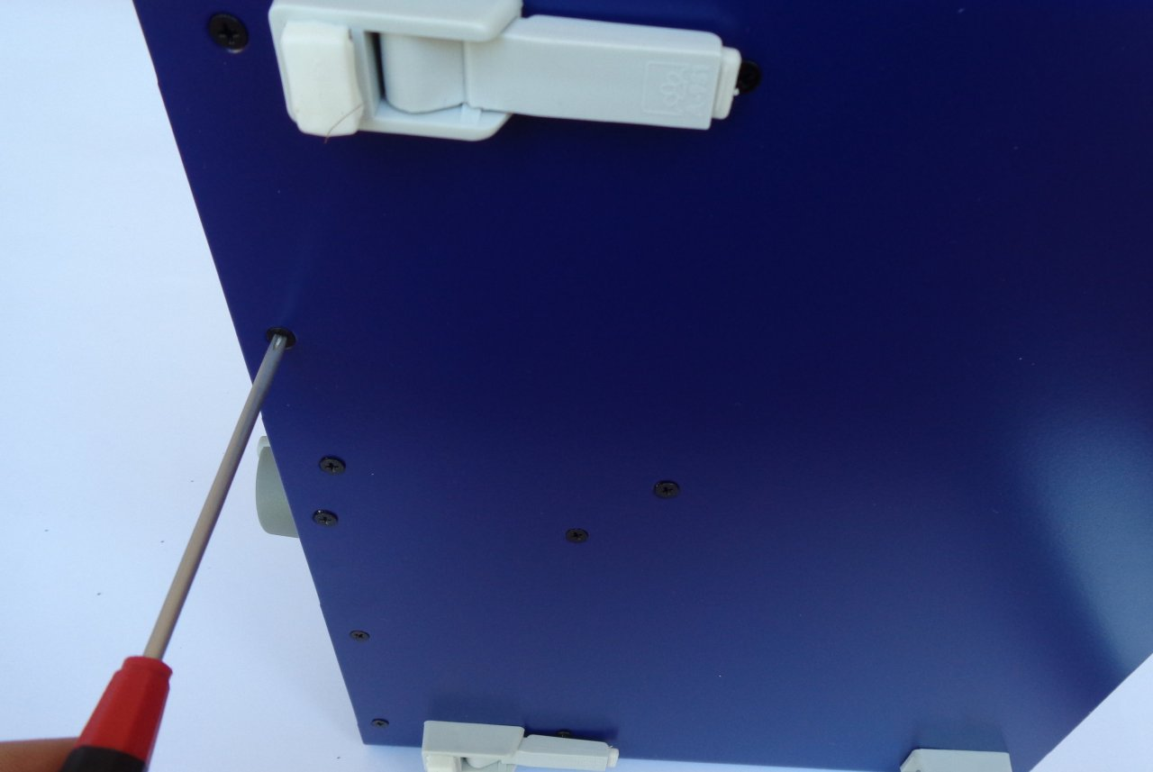Fig. 14: Fixing the front panel from below to the bottom plate
Fix the front panel to the bottom plate (Fig. 14) with two M3 screws (item M) in the positions shown in Fig. 4. Continue the installation by fixing the front panel to the sides of the bottom plate with another two M3 screws (item M) as shown in Fig. 15. Check again that the user switch is working and then you can tighten the 8 screws that hold the MCU and BP3C to the bottom plate.
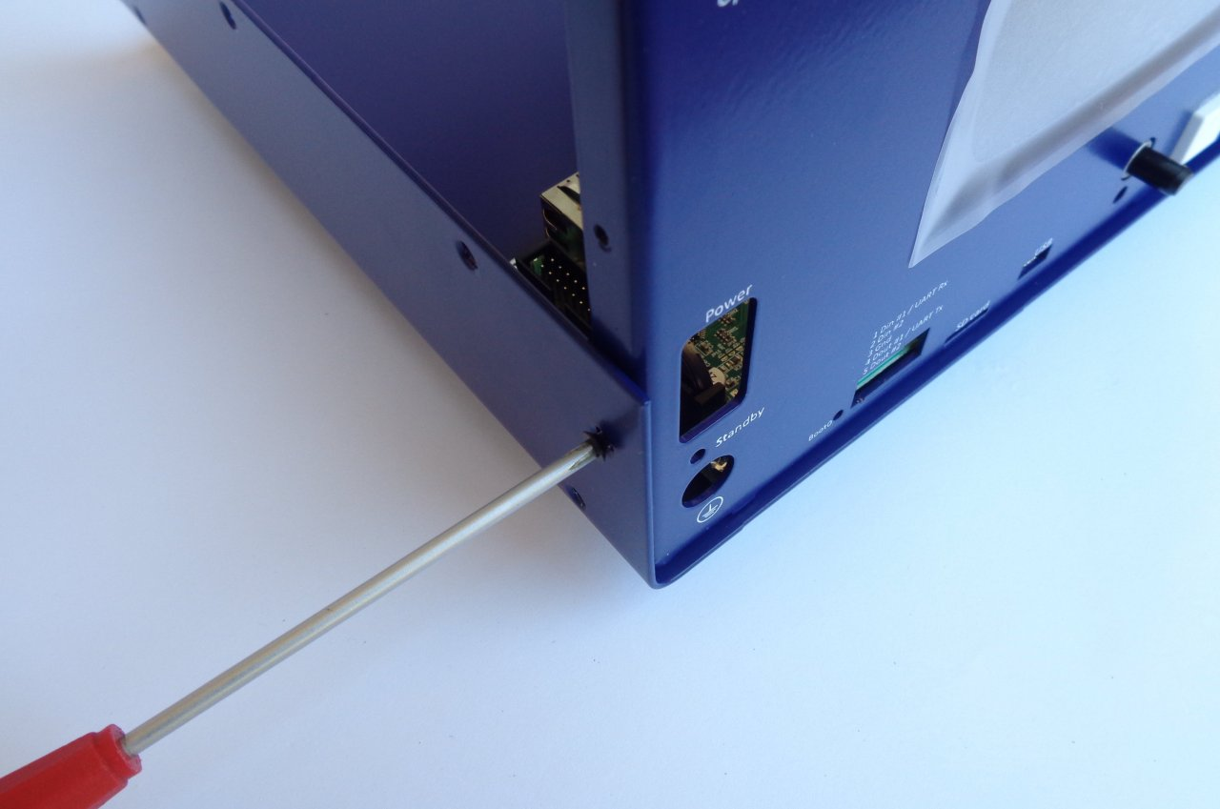Fig. 15: Fixing the front panel from side to the bottom plate

The encoder knob now can be mounted. Take care that the notch on the encoder shaft matches the flat on the knob when inserting the knob (Fig. 16).
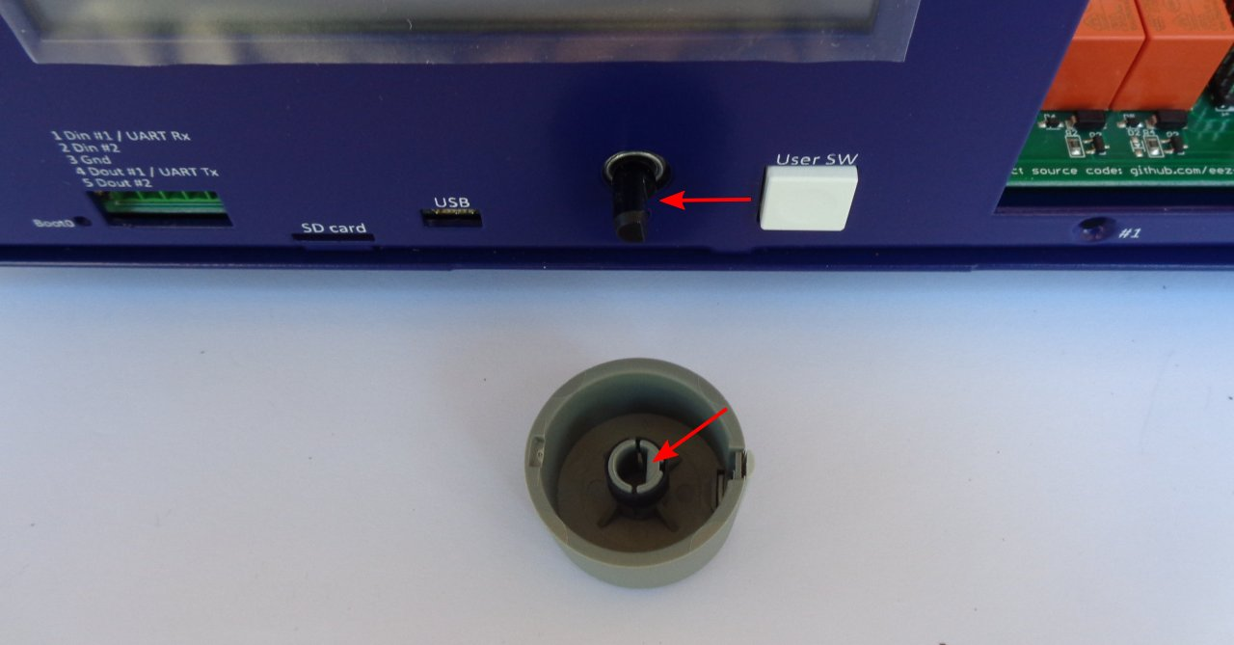Fig. 16: Encoder knob before mounting

Installing AUX-PS module
Remove the AUX-PS module from the package and attach the hexagonal metal spacers (J) using screws (L) in the five holes of the module.

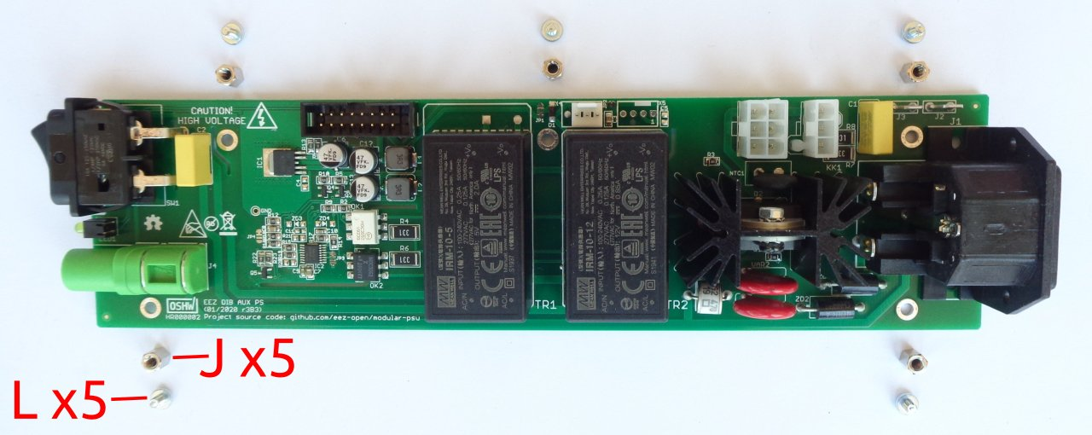Fig. 17: AUX-PS module with mounting parts
The AUX-PS module should be attached to the rear panel with two screws and nuts (content of bag K in Fig. 3). This is easiest to do before the AUX-PS is mounted on the bottom plate, because it makes it easier to access the nuts during mounting (Fig. 18).

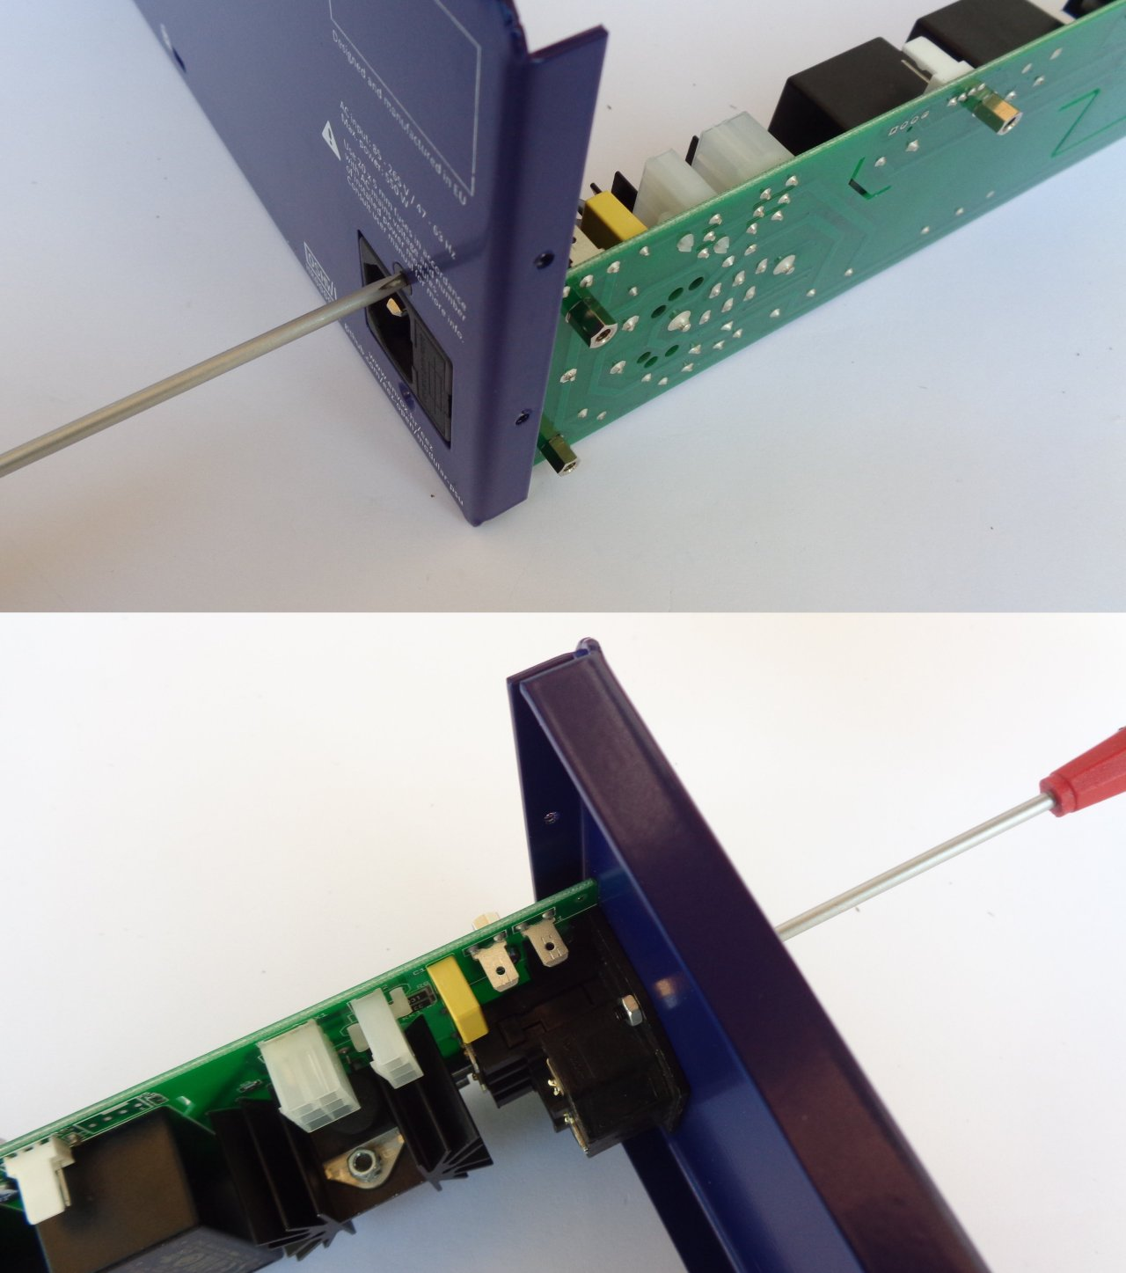Fig. 18: Mounting AUX-PS module to the rear panel
Continue installing the AUX-PS module by carefully inserting it from the back making sure that the Standby LED and power switch enter its holes in the front panel. When the AUX-PS module is inserted, you can secure it with 5 screws (item M) on the side of the bottom plate (Fig. 19).

Rear panel mounting and cable connection
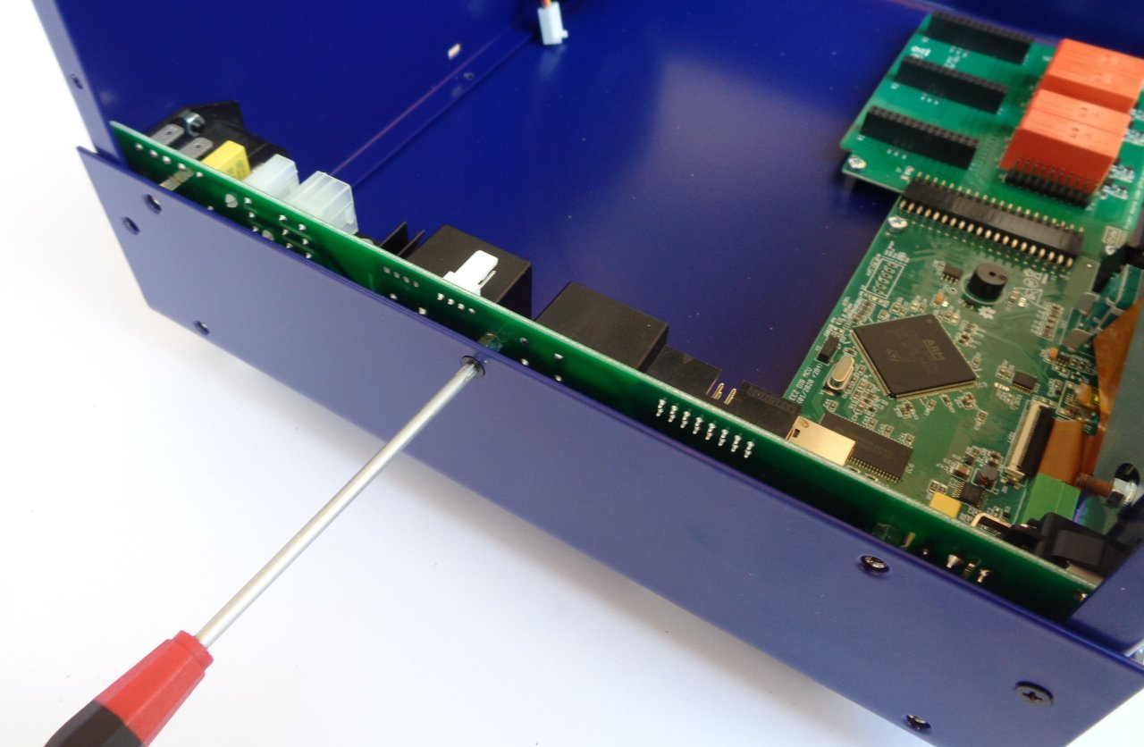Fig. 19: Fixing the AUX-PS module on the bottom plate
Attach the rear panel to the bottom plate. This will require three screws (item M).

Ethernet connection will require a patch cable (item A) and two screws (item M) as shown in Fig. 21.
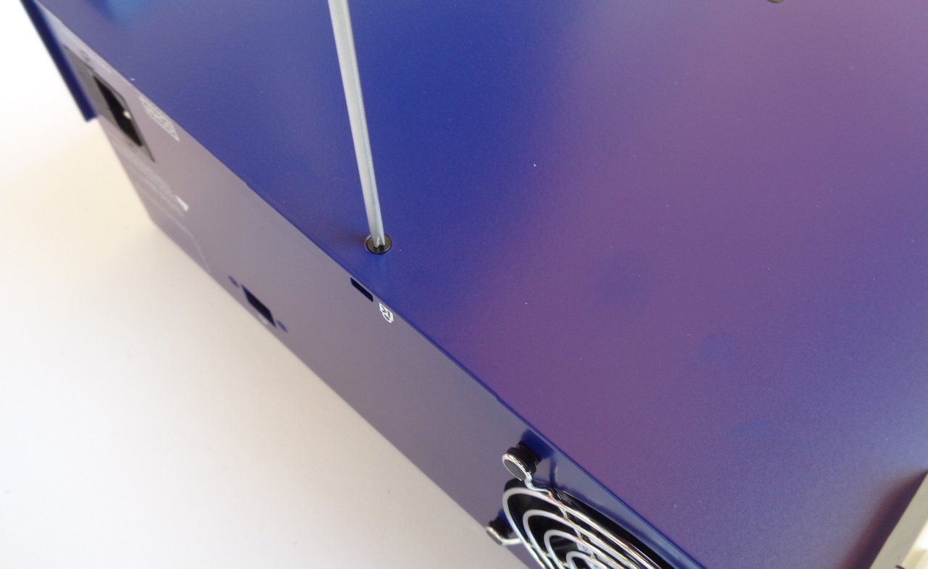Fig. 20: Rear panel mounting

First, carefully insert the plug at one end of the Ethernet patch cable into the MCU module. Then secure the other end to the rear panel. Next, connect the cooling fan connector to the AUX-PS module as shown in Fig. 22. Fig. 23 shows the mounted Ethernet patch cable.
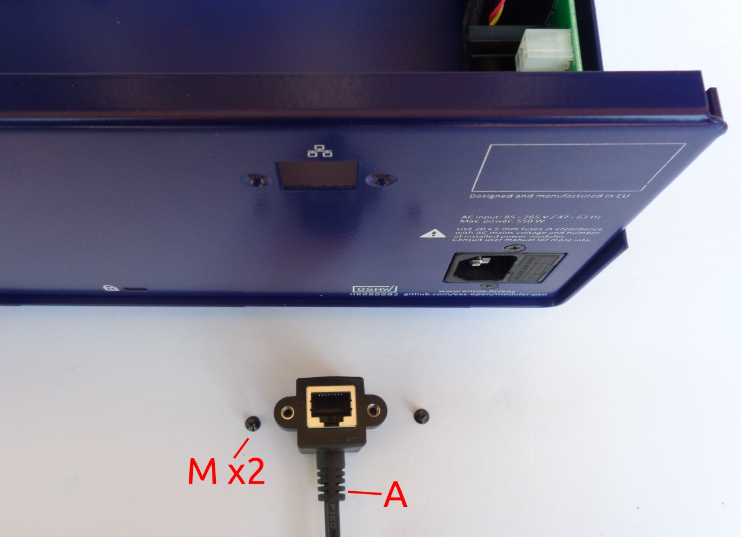Fig. 21: Ethernet connection mounting parts

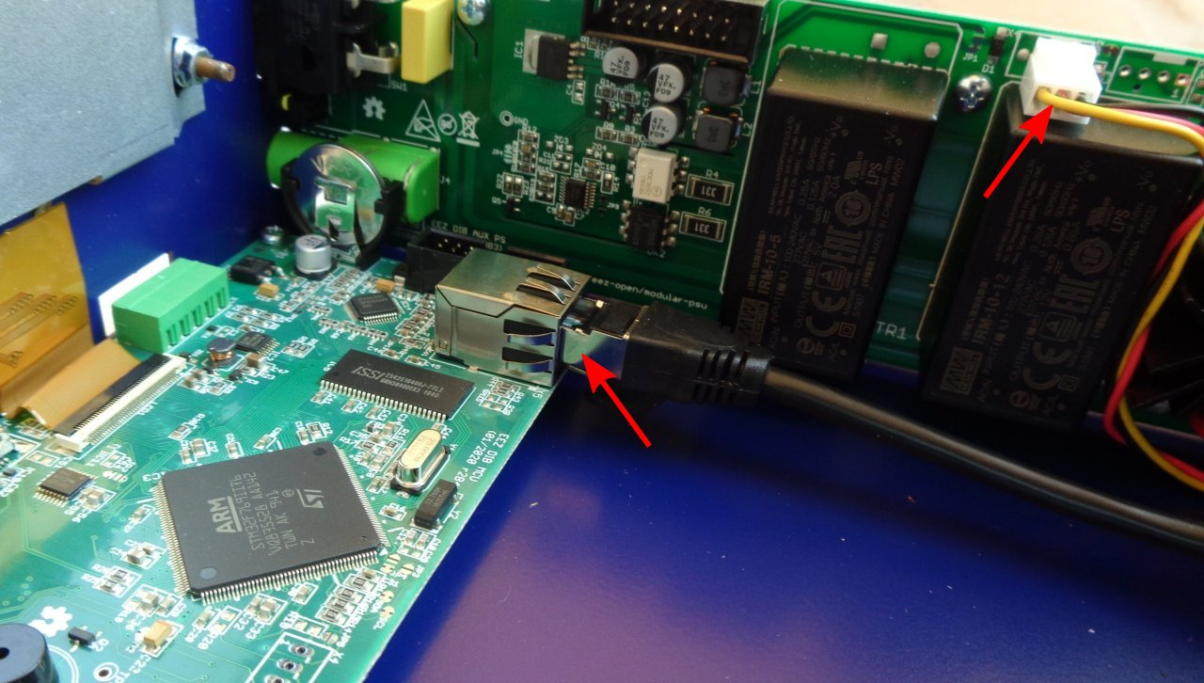Fig. 22: Connecting Ethernet and cooling fan cables
Finally, you can connect the AUX-PS and MCU module with a 16-pin IDC flat cable (item F) as shown in Fig. 24.
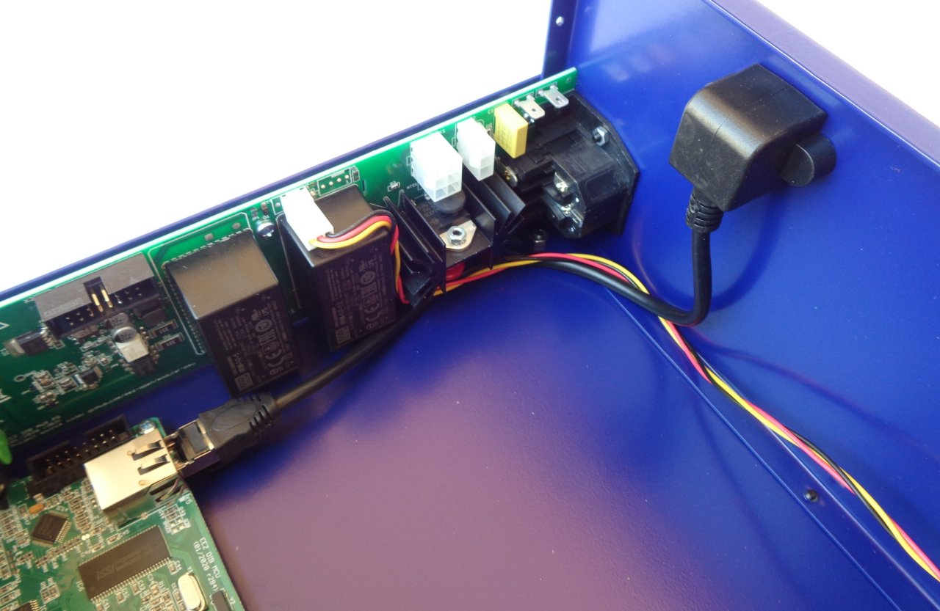Fig. 23: Mounted Ethernet patch cable

First power up and installation of power modules
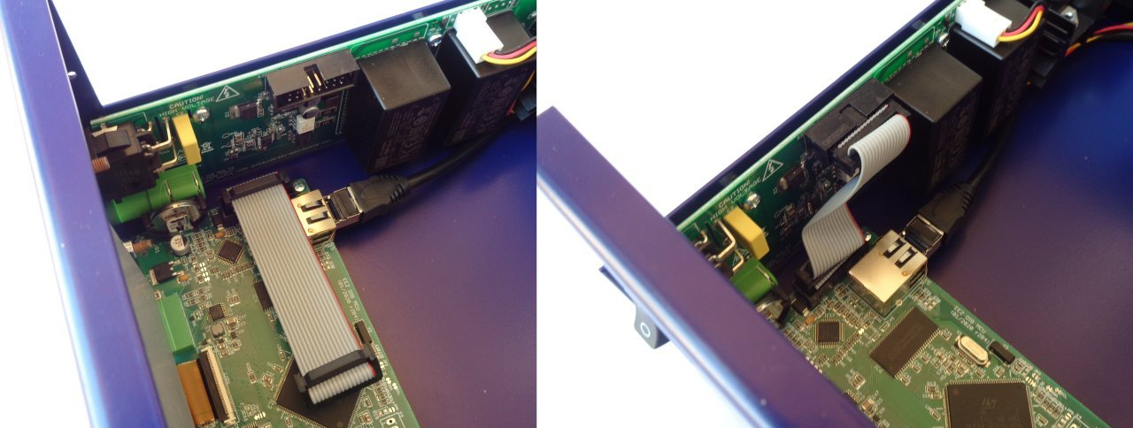Fig. 24: 16-pin IDC cable mounting

The MCU module comes with the firmware installed. It is now possible to do a trial power up. Take the power cord used in your country (not included in this kit) and turn on the unit using the front panel power switch. If everything is connected properly, a welcome message will appear on the display. You can tap the red colored icon at the bottom right of the status bar to see that the micro SD card is not installed.
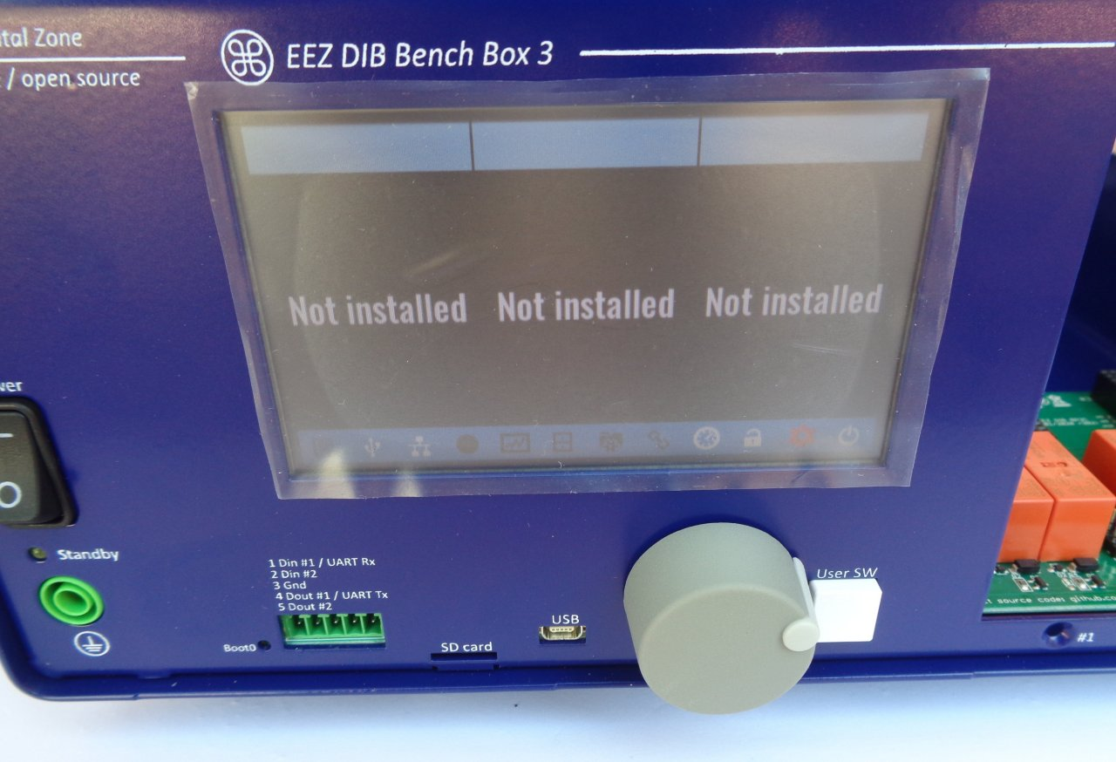Fig. 25: Test power up without peripheral modules or micro SD card
You can now insert the micro SD card. Carefully remove it from the package and insert it as shown in Fig. 26 with the pins facing up.

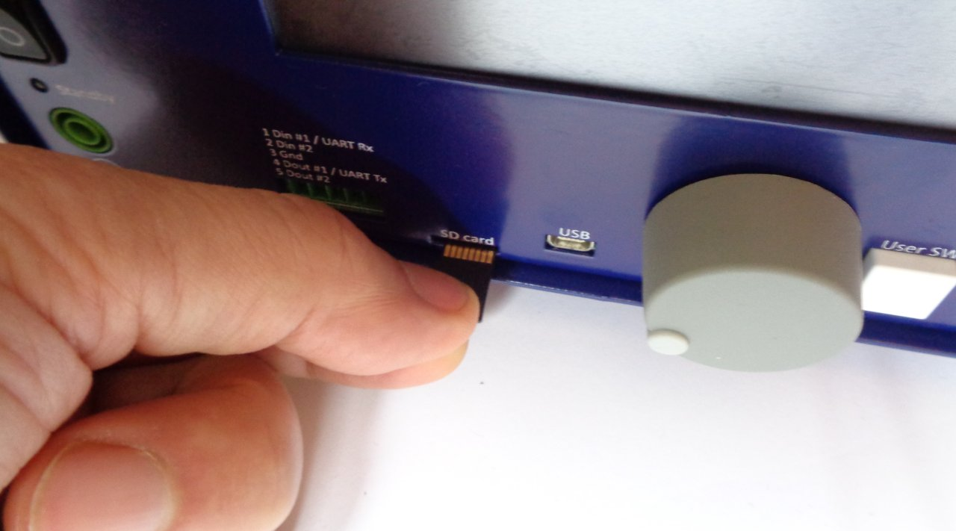Fig. 26: Inserting micro SD card
Turn off the unit and unplug the power cord before continuing.

Power modules (Item 8, Fig. 2) require 48 VDC. Mean Well AC / DC converters are used for this purpose (Item 9. Fig. 2). Fig. 27 shows the connecting cables and terminal covers. Note that the dual AC power cable has two arms of different lengths (Fig. 28). The shorter cable goes to Mean Well, which will be closer to the AUX-PS module as shown in Fig. 29.
First, carefully connect the cables as shown in Fig. 28. Take care of the colors of the wires. When cables are connected, the terminal covers (item N) can be mounted.

AC Line
AC Neutral
Protective Earth (PE)
Vout-
Vout+

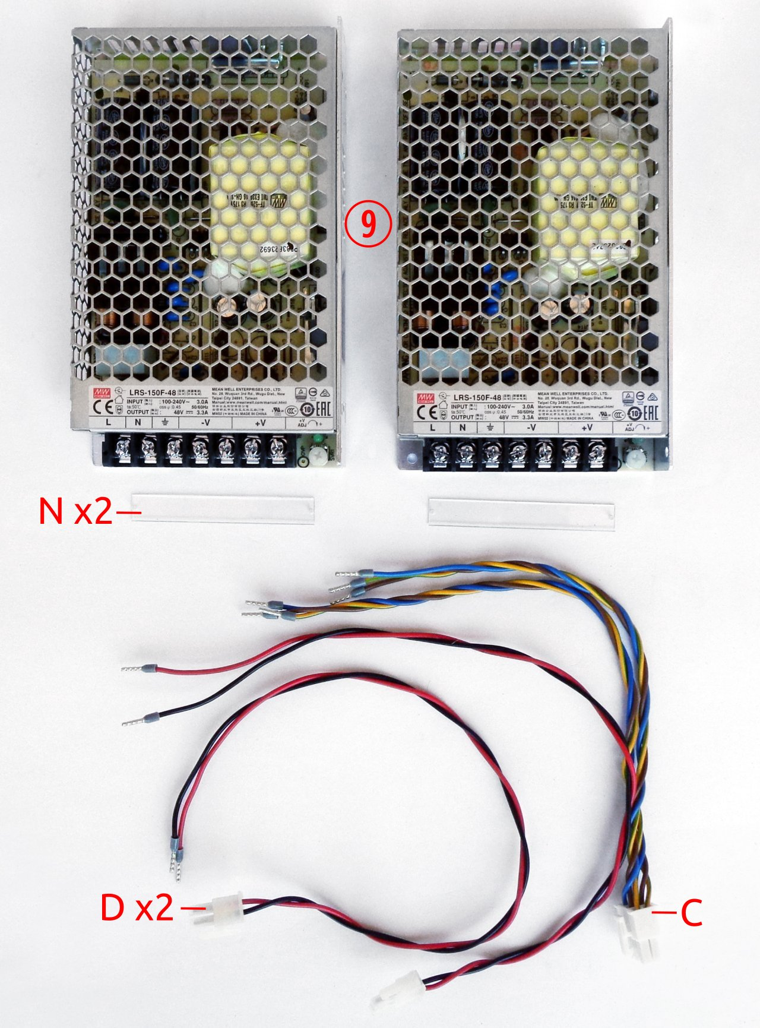Fig. 27: Mean Well AC/DC converters and related wiring
Mean Well converters are mounted on top cover. The mounting frame (item 5) is used for this. Each converter is attached to the mounting frame with two screws (item M) as shown in Fig. 29. As mentioned above, the converter with the shorter AC power cable should be mounted to the far left position.
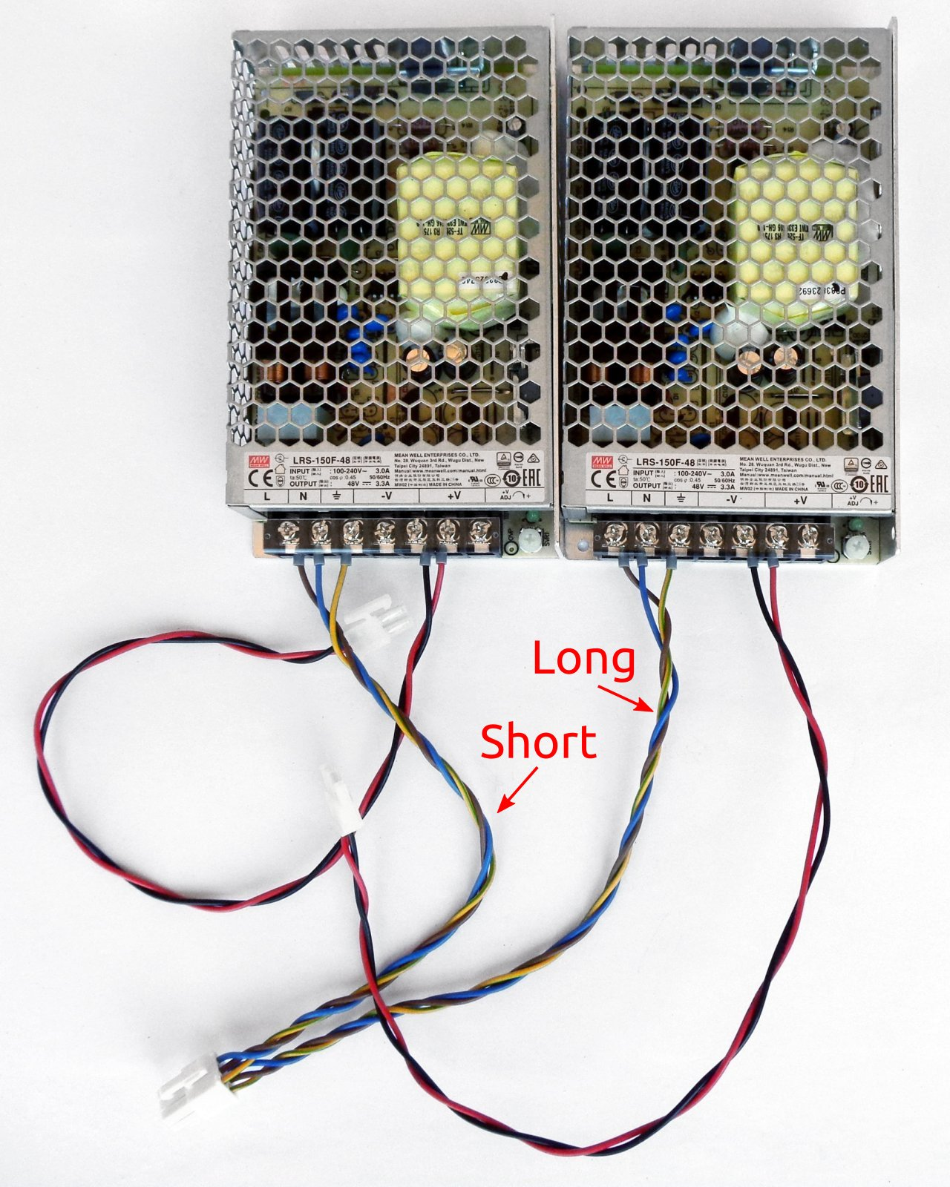Fig. 28: Mean Well AC/DC converters with installed terminal covers and cables

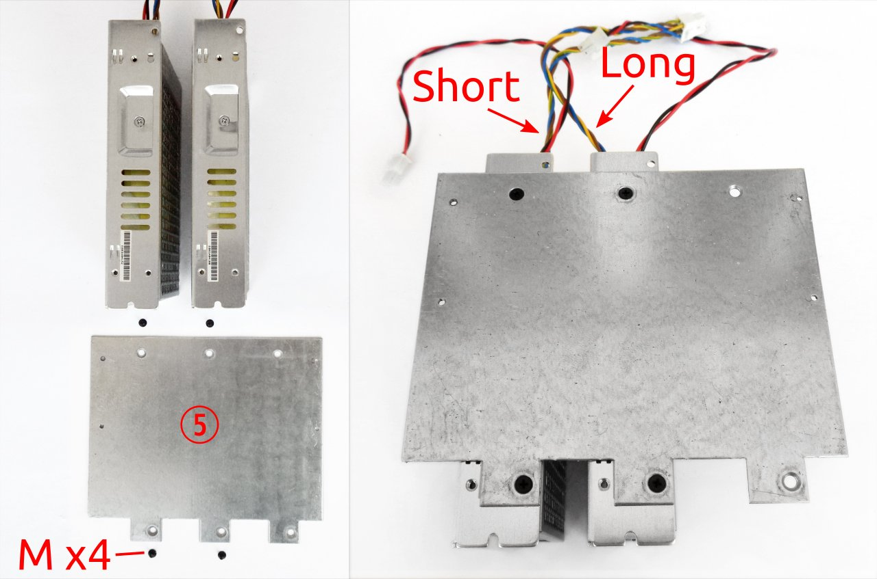Fig. 29: Mean Well AC/DC converters with mounting frame
When the converters are attached to the mounting frame, the top cover should be placed over them as shown in Fig. 30. Secure it with four screws (item M).

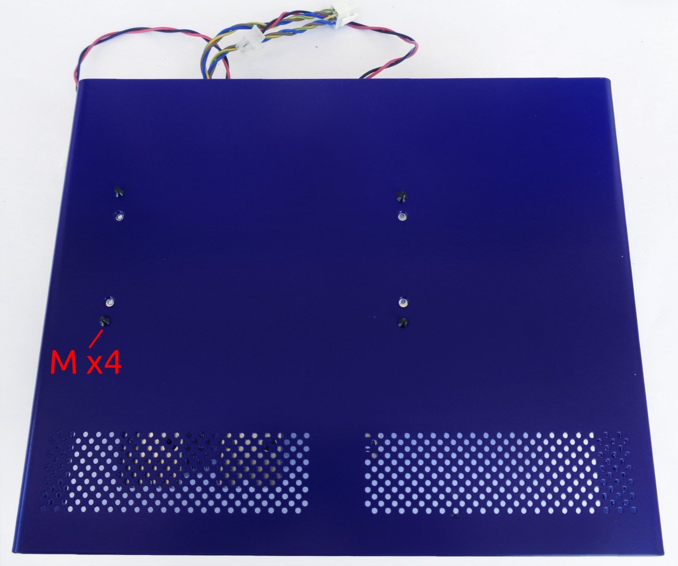Fig. 30: Top plate placed on top of AC / DC converters
Place the top cover with the mounted converters behind the rear panel and plug the AC power connector into the AUX-PS module as shown in Fig. 31. You can now also attach the PE cable to the corresponding place (item B, Fig. 3).

Use cable ties (item I, Fig. 3) to secure the cables. An example is shown in Fig. 32.
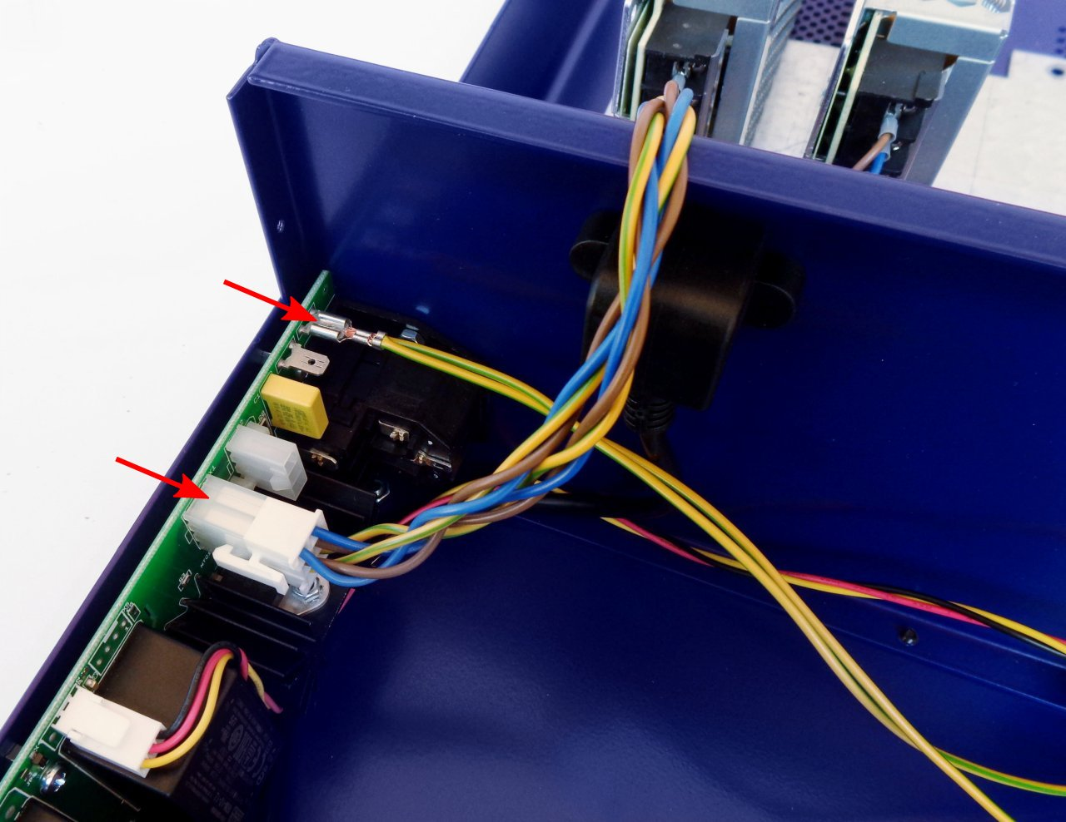Fig. 31: AC power input and PE connections

To install the power module, you will need two screws each module. Unless you have also purchased a third module, the blind front panel (item E) will be used to close the third slot (Fig. 33).
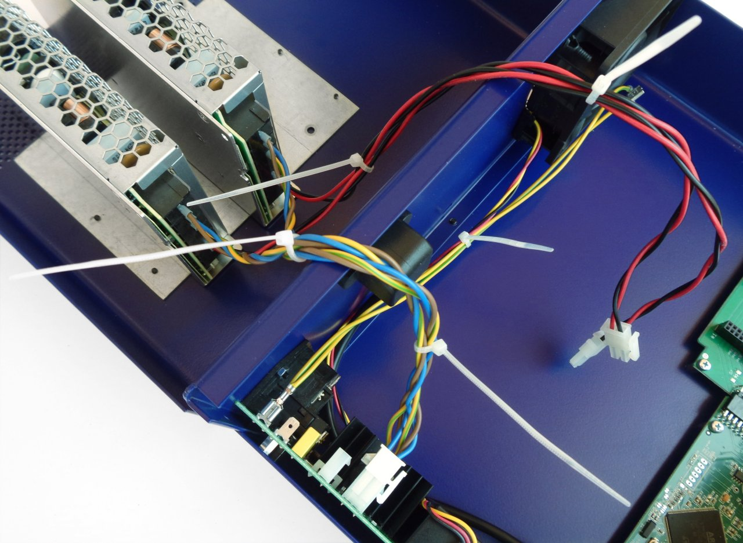Fig. 32: Cable ties

The power module (item 8, Fig. 2) should be connected with the DC cable (item D) coming out of the Mean Well converter and the PE cable (item B) that we connected to the AUX-PS module as shown in Fig. 34.

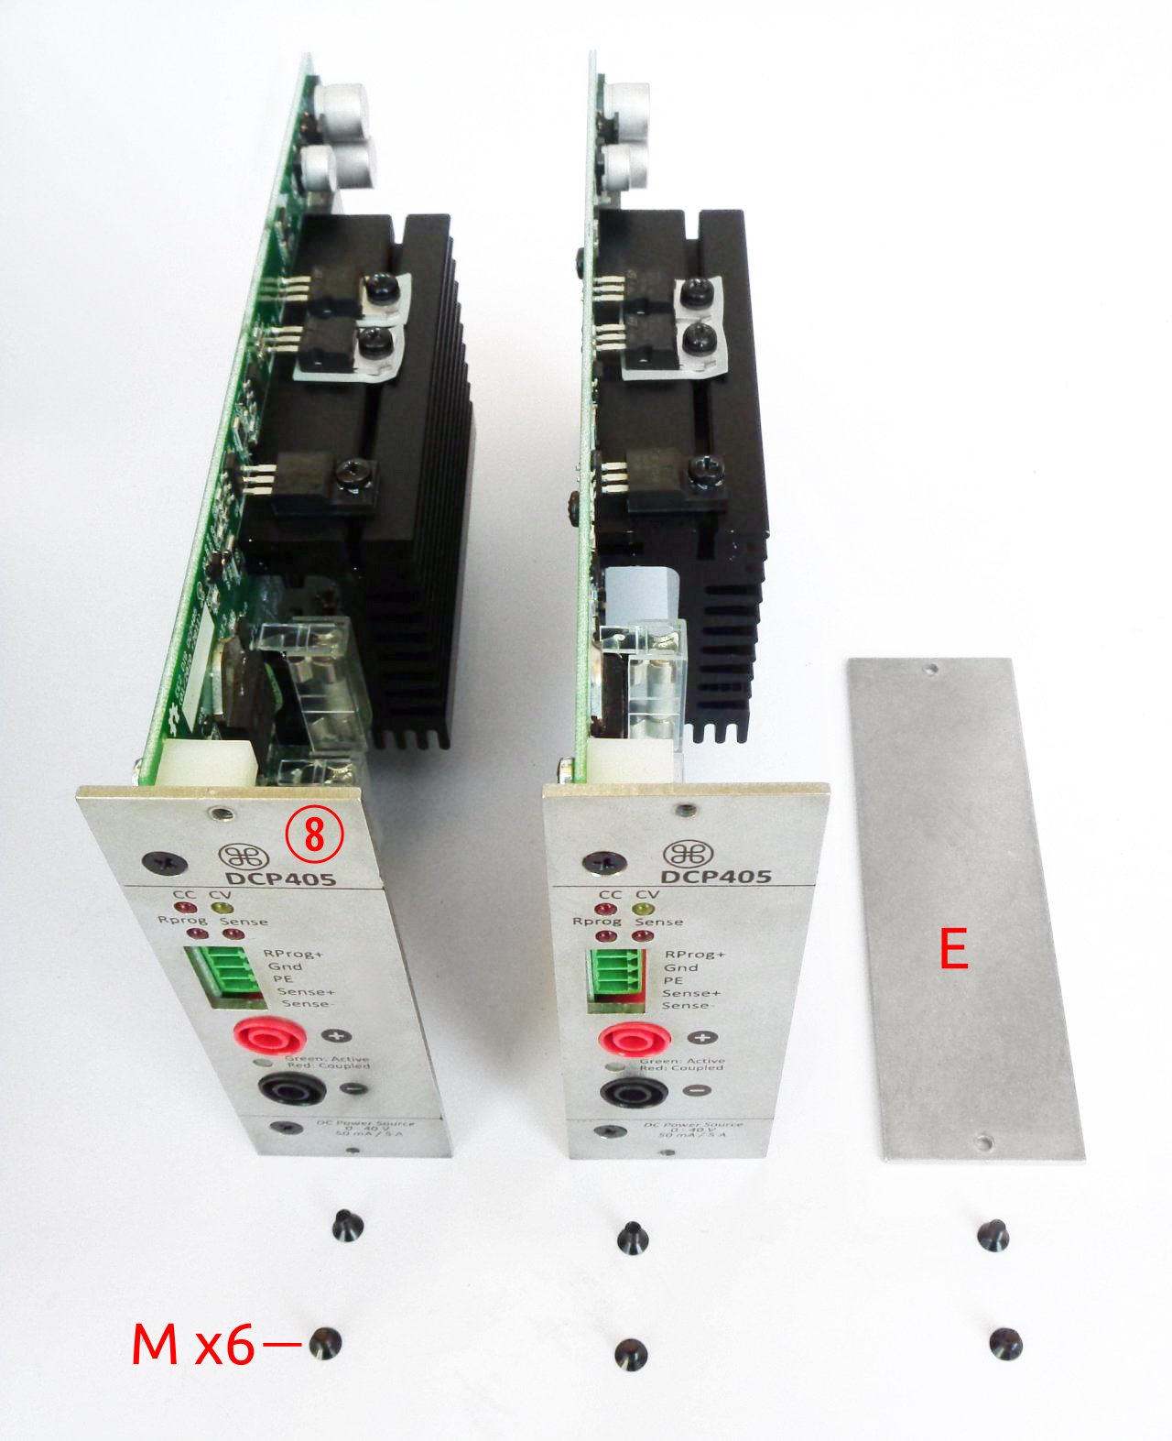Fig. 33: Power modules mounting parts

After connecting the power and the PE cable, we can continue with inserting the module into the BP3C backplane (Fig. 35)
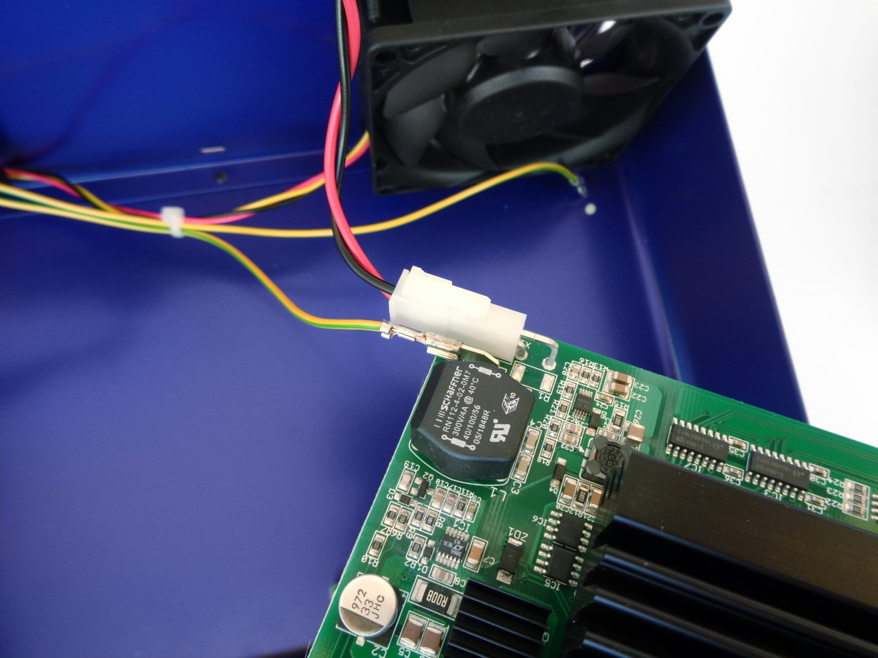Fig. 34: Power module input connections

Once the power module is securely inserted into the backplane slot, it should be fixed with two screws. First install the screw in the lower hole, and then a second screw into the upper hole.
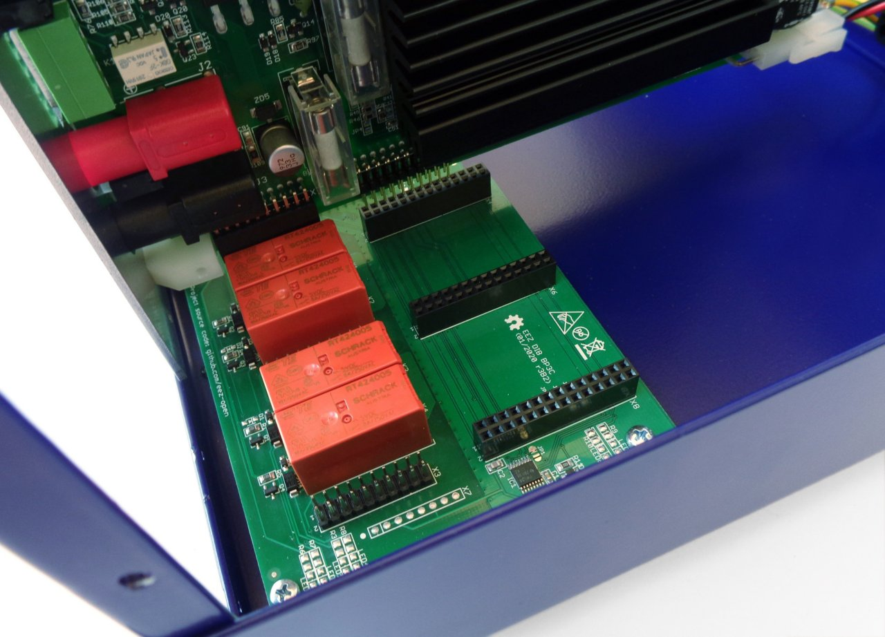Fig. 35: Power module insertion

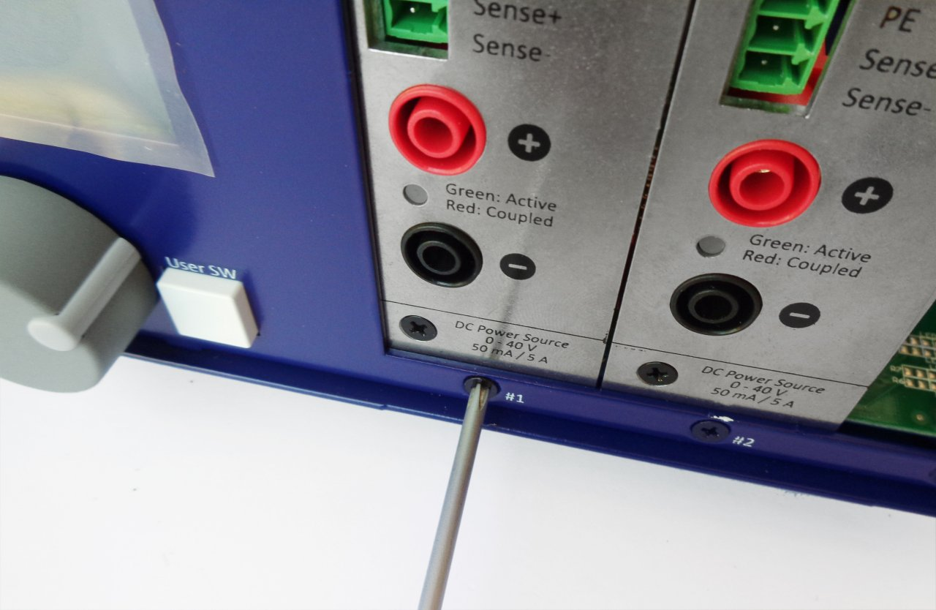Fig. 36: Power module fastening
Before closing the enclosure, make sure that the power module's connecting cables do not interfere with the cooling fan (Fig. 37).

Carefully fold the cables coming from the Mean Well converter and place the top cover on the enclosure. Secure it with four screws (item M): first on the rear panel and then on the front panel.
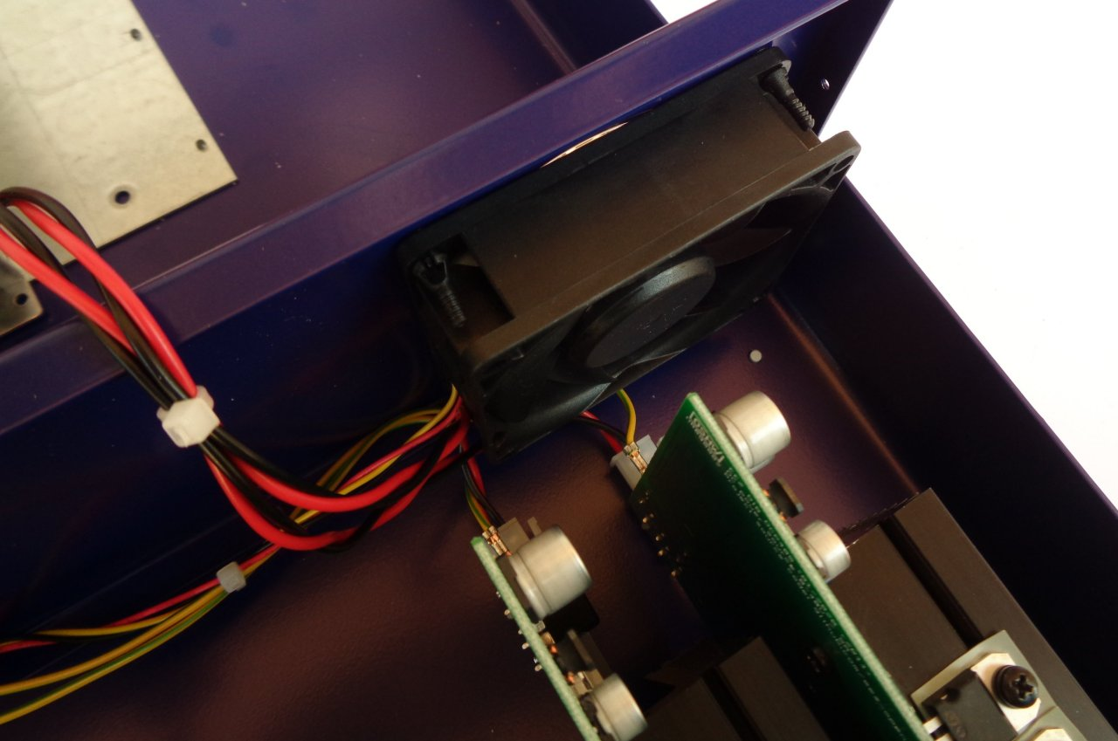Fig. 37: Power module wiring check

User manual and firmware update
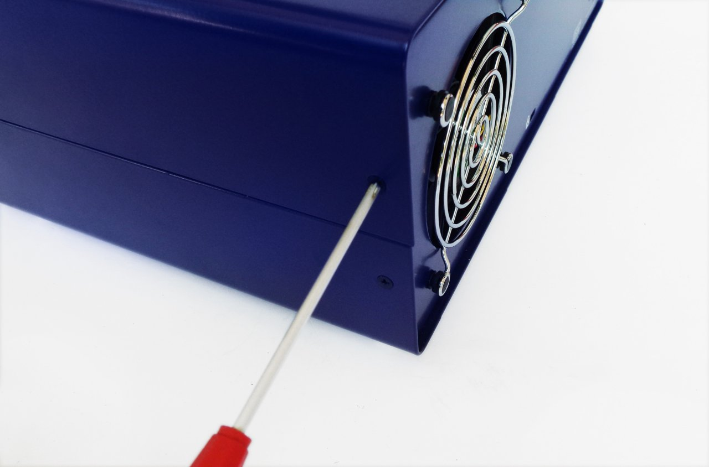Fig. 38: Securing the top cover
Turn on the power with the power switch on the front panel and if the self-test procedure is successfully completed, the start page will be displayed as in Fig. 39.

The EEZ BB3 User manual is available online as well as in downloadable PDF format. For advanced users, the SCPI programming guide is also available online.
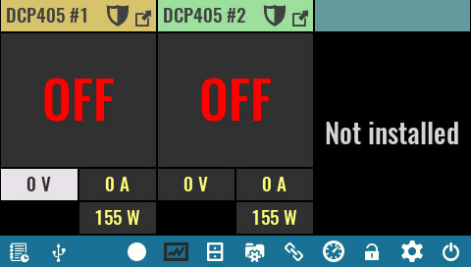Fig. 39: Home page with two power modules initiated

We are constantly working on firmware, removing bugs and improving it. There is a chance that the firmware that was shipped is not the last released version. Upgrading to the latest version is recommended. You can find information about the installed version on the System Information page or by sending a *IDN? SCPI query. You can find information about the latest released version on the Firmware page.

